**Citi Bike Analysis**

**This document explores monthly Citi Bike data and summarises the main findings.**

The data source utilised for this analysis contains information relating to the where, when, how, and which details of the riders on the program.

**Please refer to the published Tableau workbook for full visual interactivity.**

[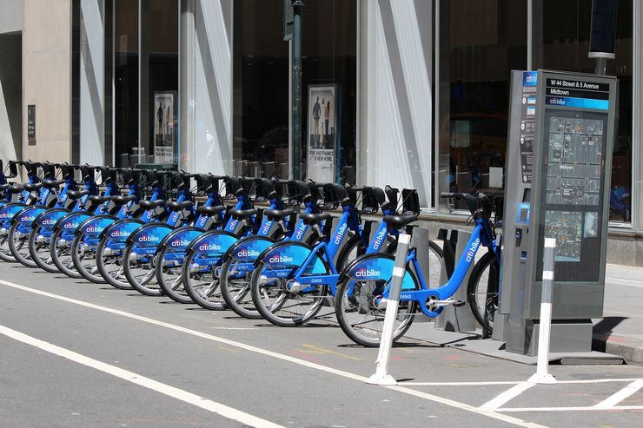](https://www.tourbytransit.com/newyorkcity/public-transit/citibike)

**Disclosures before viewing the findings:**

* The data utilised in this analysis was processed to remove trips that are taken by staff as they service and inspect the system, trips that are taken to/from any of Citi Bike “test “stations, and any trips that were below 60 seconds in length (potentially false starts or users trying to re-dock a bike to ensure its secure). (Citibike 2023)
* Please read this analysis as a guidance, all findings have been concluded based on this dataset and may be limited to certain biases which change according to the context considered. The analysis contains multiple likelihoods/ hypotheses which would need to be researched further to be validated.
* Prior to analysis, the data set was cleaned; irrelevant rideable types such as docked bikes were removed, any records which did not have a start or end station were removed to avoid distortion of the results.

**Phenomena 1 – January vs June Trends:**

The above visual shows the number Citi Bike rides in January and June (2022-2023), the visual is split by if the rider was a member or not to help visualise the growth for each rider type.

**Insights**:

1. Citi Bike has a higher demand of bike rides amongst members than casual riders.

2. The growth in casual riders between January and June is significantly greater than the growth in members in the same period, this is demonstrated by the 254% and 108% increases respectfully.

This could be due to people dedicating their time to leisurely bike rides due to more tourist openings, summer holidays periods where people have more disposable time, and better weather which means there is an increase in individuals who simply want to use the service on a one-time basis.

Out of the 148 stations, 62 did not have a single ride during the month of January; including Broadway stations which is likely to be linked with being used for tourism purposes only.

With this being said, members growth is still large, although it is not as exponential as casual riders, this growth could be due to people being more motivated to focus on their health on a consistent basis during June or perhaps is linked to better marketing.

3. The number of riders has exceeded a doubled value rise from January 2022 to January 2023. However, the number of casual riders dropped by approximately 11,000 in June 2023 in comparison with the same point the prior year.

The above visual shows the number Citi Bike riders for each hour in the day, this helps to gage which times are the busiest and quietest.

**Insights:**

1. The number of riders starting a ride during the first hour of the day (12:00pm-1:00am) is doubled in June compared with January, the difference is more significant in 2022 in comparison with 2023, this could be related to the population demographic and the structure of age groups as certain ages are more likely to be awake and use a bike during these early hours. Both months also share the most super off-peak hour of 3:00am which is feasible as this is the time the majority of the city would be asleep at.

2. The small amount of very early riders tend to start their rides between 4:00am-5:00am, these individuals may have a longer commute or have a less common shift pattern. However, ride volume picks up pace much more rapidly after 5:00am and peaks at 8:00am; the riders who use Citi Bike for communicating has a peak time of 6:00am to 8:00am.

3. The highest volume of riders in January started their ride just after 17:00pm, however, this differs in June where the highest volume of riders peaks just after 18:00pm; this could be due to daylight hours.

4. The number of riders between 11:00am and 12:00pm increases more rapidly in June in comparison with January. This is not expected as the time frame is not a direct link with a lunch hour, perhaps there are certain companies which allow early lunches during the summer months or flexible working.

5. When filtering to the day of the months which lie on weekends, for example January 14th, 2023, the peak morning hour changes to 10:00/ 11:00am.

6. Overall, the most peak time for a Citi bike rider is at 18:00pm in June.

Overall, the average bike ride duration is 4 minutes longer in June. In 2022 the average bike ride was 5 minutes longer in June whereas it was only 2 minutes longer in 2023.

Factors which may explain the difference:

* The weather tends to be colder in January, especially in the area where the Citi Bikes are located where temperatures tend to fluctuate between 4 and -3 degrees in January compared to 22 and 12 degrees in June. People are therefore likely to intentionally use the bikes for essential shorter journeys due to this to avoid the harsher weather conditions; people would much rather enjoy riding a bike for longer in a warmer June.
* In June, cyclists may have set goals to be in the best shape they can be and are training for some sort of event, therefore they cycle for longer to get more training in.
* In June, tourists may want to explore different areas more and therefore take longer casual bike rides which cause the overall average bike ride duration to increase.

In the published workbook, you can visit the January vs June Dashboard to uncover additional hidden trends yourself. This dashboard is interactive, you can click on certain parts of the visuals to highlight your focus and filters will apply across all visuals within the dashboard.

**Dashboard observation:**

1. In June, the overall average bike ride duration was longer compared to January, it is also notable that there are more people riding bikes during June than January till later on in the day from the other visuals present on the dashboard. Therefore, it could inferred that due to deviation in the population of riders, people who are able to ride for longer also increases due to probability.

**Phenomena 2 – Ride Durations:**

The above visual displays the average bike ride duration broken down by weekday.

**Insights:**

1. People have more free time on a weekend to focus on their fitness/ go on a leisurely bike ride. This is displayed as Sunday and Saturday are the days with the highest bike ride duration for both classic and electric bikes.

2. Sunday is the day where people ride on a Citi Bike for the longest duration and Wednesday is the day where people ride on a Citi bike for the shortest duration. Although it is not immediately obvious why, it could by hypothesised that with Wednesday being mid-week, it is the busiest day in people's lives and therefore, they cycle faster as they are in a hurry.

3. Casual bikers have a longer bike ride during the weekends, but electric bikers have a longer bike ride duration during the week when compared to the opposing bike type.

The above visualisation capture the top 20 stations which had the highest average rider durations. The darker the shade of blue the higher the average duration.

**Insights:**

1. Overall, the station: Broadway & W 41 St had the highest average rider ride time of 102 minutes, this could be due to the many tourist attractions which are accessible near this station such as the Empire State Building, Grand Central Terminal, and the Whispering Gallery to name a few. With the station being located in this area, people are likely to be using their Citi Bike for leisurely purposes which explains why it holds its duration rank.

2. Division St & Bowery is the station with the highest average ride time during the morning, this station is located within commutable distances to office spaces and therefore, individuals may choose to use Citi bike, so they do not get caught up in work traffic. It could even be the case that business organisations close to this station offer employees incentives for commuting to work via bike for environmental governance.

In the published workbook, you can visit the Ride Duration Dashboard to uncover additional hidden trends yourself. This dashboard is interactive, you can click on certain parts of the visuals to highlight your focus and filters will apply across all visuals within the dashboard.

Hover over elements on the visuals to uncover tool tips to assist with further insights.

**Dashboard observation:**

The station with the highest average duration differs per weekday. For example, On Sundays, 5 Ave & E 87 St is the station with the highest ride duration, whereas on Tuesday, Wednesday, and Saturday the station with the highest duration is Bergen Ave & Stegman St. Finally, as expected on Friday Broadway & W 41 St has the highest duration so perhaps this is the day which is most ideal for tourists to visit and therefore they take longer rides.

**Requested – Map Visualisations**

The above map represents each start station as a circle marker, the marker's intensity gets deeper with the number of rides recorded at that station. The numbers seen on the map are an overlay which represent the zip codes of the area.

**Insights:**

1. The most popular start stations are located in the zip codes: 07030 and 07302. Any stations located in 07030 which are a lighter blue are not as busy and may want to be reviewed to check if it would be feasible to open up any tourist spots near them to incentivise individuals to visit these areas to evenly distribute the number of rides being taken from the currently popular start stations.

2. Some popular stations include:

* Broadway & W 41 St
* Hoboken Terminal - Hudson St & Hudson PI
* City Hall - Washington St & 1 St
* South Waterfront Walkway - Sinatra Dr & 1 St
* Newport Pwky

For these stations, it may be best to review the health of the bikes being used.

3. Bergen Ave & Sip Avenue is quite a busy station in zip code 07306 but is not surrounded by many other stations, perhaps some more Citi Bike stations would be beneficial in this location.

The above map represents each end station as a circle marker, the marker's intensity gets deeper with the number of ride ends recorded at that station.

**Insights:**

1. Most people are travelling towards the North in zip code 07030, this zip code is near numerous tourist and sightseeing attractions such as NYC skyline tour and seeing NYC across the Hudson.

2. Although some individuals started their journey in zip code 07305, no individuals ended their journeys back here.

3. Grove Street Path is also a popular end location, it is a bit further out from primary tourist activities but is still accessible, therefore, it is slightly cheaper to stay in this area compared to Manhattan hotels.

In the published workbook, you can visit the Map Dashboard to uncover additional hidden trends yourself. This dashboard is interactive, you can click on certain parts of the visuals to highlight your focus and filters will apply across all visuals within the dashboard.

Hover over elements on the visuals to uncover tool tips to assist with further insights

**Dashboard observation:**

There is a trend that many people start their journey from further out from the tourists attractions and travel towards the coastal areas where there are more activities. The areas where there are less riders starting are likely to be travelling north.

For a quick overview of the visuals created, please visit the Citi Bike Analysis tab in the published workbook to view the story of the insights uncovered.

